表1 恒定磁场下V_{H}与I_{S}的关系 I_{M} = 0.200 A
I_{S}  (mA) | V₁ (mV) | V₂ (mV) | V₃ (mV) | V₄ (mV)
 | +I_{S}, +B | +I_{S}, -B | -I_{S}, -B | -I_{S}, +B
0.200 | 5.63 | 5.740 | 5.76 | 5.65 | 5.70
0.400 | 11.33 | 11.54 | 11.55 | 11.32 | 11.44
0.600 | 16.95 | 16.95 | 17.25 | 16.94 | 17.02
0.800 | 22.52 | 22.95 | 22.97 | 22.52 | 22.74
1.000 | 28.17 | 28.68 | 28.72 | 28.15 | 28.43
1.200 | 33.68 | 34.32 | 34.36 | 33.54 | 33.98
1.400 | 39.11 | 39.79 | 39.93 | 39.04 | 39.47
1.600 | 44.59 | 45.40 | 45.47 | 44.45 | 44.98
1.800 | 49.99 | 50.87 | 50.98 | 49.88 | 50.43
2.000 | 55.30 | 56.27 | 56.40 | 55.20 | 55.79

表2 恒定工作电流下V_{H}与I_{M}的关系 I_{S} = 2.000 mA
I_{M}  (A) | V₁ (mV) | V₂ (mV) | V₃ (mV) | V₄ (mV)
 | +I_{S}, +B | +I_{S}, -B | -I_{S}, -B | -I_{S}, +B
0.020 | 5.30 | 7.02 | 7.04 | 5.32 | 6.17
0.040 | 10.79 | 12.01 | 12.11 | 10.28 | 11.30
0.060 | 16.55 | 17.73 | 17.91 | 16.02 | 17.05
0.080 | 22.05 | 23.22 | 23.41 | 21.58 | 22.57
0.100 | 27.56 | 28.70 | 28.93 | 27.17 | 28.09
0.120 | 33.06 | 34.16 | 34.44 | 32.69 | 33.59
0.140 | 38.42 | 39.50 | 39.75 | 38.11 | 38.95
0.160 | 43.94 | 45.01 | 45.27 | 43.66 | 44.47
0.180 | 49.45 | 50.51 | 50.76 | 49.25 | 49.99
0.200 | 54.96 | 55.96 | 56.19 | 54.78 | 55.47

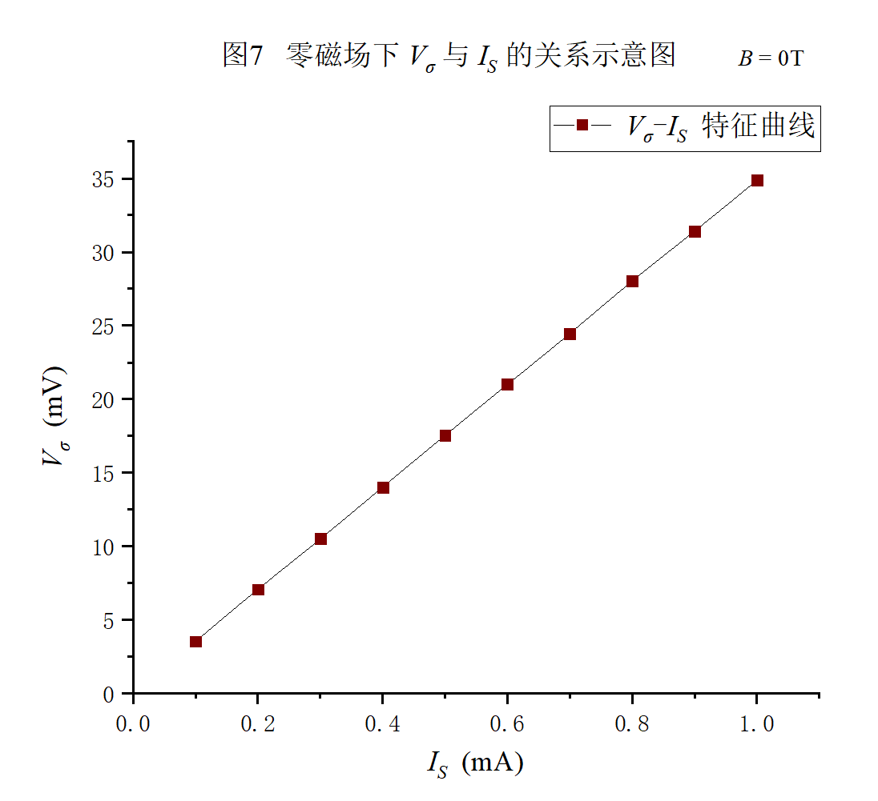
表3 零磁场下V_{σ}与I_{S}的关系 B = 0 T
I_{S} (mA) | 0.100 | 0.200 | 0.300 | 0.400 | 0.500
V_{σ} (mV) | 3.54 | 7.08 | 10.51 | 14.03 | 17.54
I_{S} (mA) | 0.600 | 0.700 | 0.800 | 0.900 | 1.000
V_{σ} (mV) | 21.00 | 24.46 | 28.02 | 31.42 | 34.87
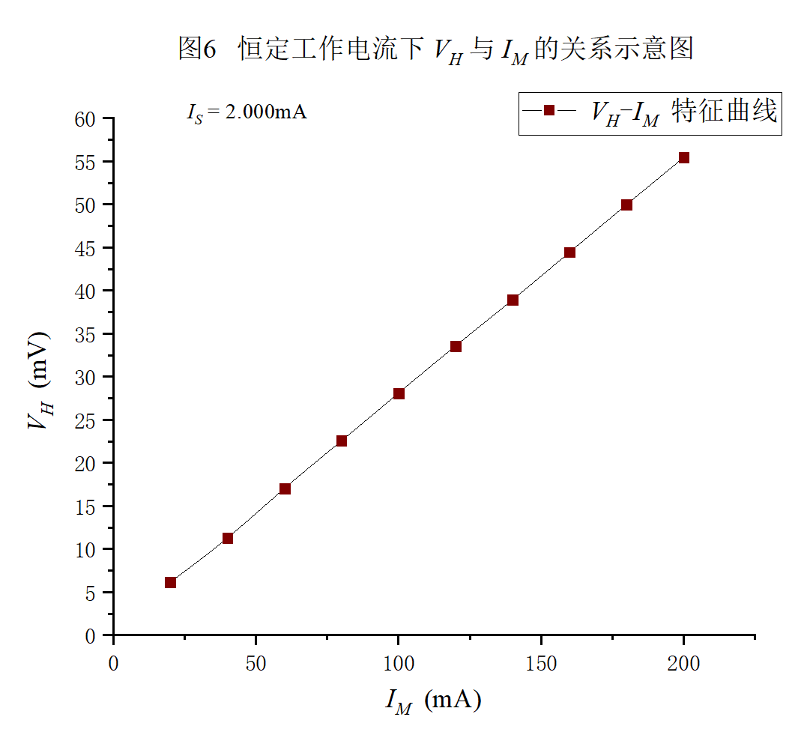

表4 电磁铁气隙中磁感应强度B在x轴方向上的分布
励磁电流I_{M} 0.200 A 工作电流I_{S} 2.000 mA
序号 | 原序号 | x_{相对}  (mm) | V₁ (mV) | V₂ (mV) | V₃ (mV) | V₄ (mV) | V_{H} (mV) | B (mT)
 |  |  | +I_{S}, +B | +I_{S}, -B | -I_{S}, -B | -I_{S}, +B
1 | 14 | -44 | 3.42 | 4.81 | 4.86 | 4.84 | 4.48 | 1.46
2 | 13 | -38 | 5.10 | 6.58 | 6.73 | 6.62 | 6.26 | 2.03
3 | 12 | -35 | 6.45 | 8.01 | 8.16 | 8.11 | 7.68 | 2.50
4 | 11 | -32 | 8.79 | 10.16 | 10.40 | 10.31 | 9.92 | 3.22
5 | 10 | -30 | 10.94 | 12.22 | 12.41 | 12.24 | 11.95 | 3.89
6 | 9 | -26 | 18.30 | 19.07 | 19.72 | 19.49 | 19.15 | 6.22
7 | 8 | -23 | 28.32 | 30.07 | 31.97 | 30.42 | 30.20 | 9.82
8 | 7 | -21 | 39.27 | 40.37 | 41.95 | 40.60 | 40.55 | 13.18
9 | 6 | -20 | 43.76 | 45.62 | 46.35 | 45.71 | 45.36 | 14.75
10 | 5 | -19 | 47.66 | 49.94 | 49.94 | 50.50 | 49.51 | 16.10
11 | 4 | -17 | 52.99 | 53.62 | 54.15 | 54.17 | 53.73 | 17.47
12 | 3 | -13 | 54.30 | 55.12 | 55.22 | 55.28 | 54.98 | 17.88
13 | 2 | -11 | 54.50 | 55.24 | 55.35 | 55.40 | 55.12 | 17.92
14 | 1 | 0 | 54.55 | 55.50 | 55.63 | 55.68 | 55.34 | 17.99
15 | 15 | +11 | 54.82 | 55.87 | 55.92 | 55.77 | 55.60 | 18.08
16 | 16 | +13 | 54.83 | 55.79 | 55.89 | 55.75 | 55.57 | 18.07
17 | 17 | +17 | 53.29 | 54.38 | 54.43 | 54.53 | 54.16 | 17.61
18 | 18 | +19 | 49.39 | 50.66 | 50.04 | 50.05 | 50.04 | 16.27
19 | 19 | +20 | 45.20 | 46.41 | 45.54 | 45.39 | 45.64 | 14.84
20 | 20 | +21 | 39.35 | 41.54 | 40.27 | 50.86 | 43.01 | 13.98
21 | 21 | +23 | 28.82 | 30.24 | 28.74 | 29.86 | 29.42 | 9.56
22 | 22 | +26 | 17.62 | 19.15 | 18.70 | 19.12 | 18.65 | 6.06
23 | 23 | +30 | 10.69 | 12.23 | 11.98 | 12.15 | 11.76 | 3.82
24 | 24 | +32 | 8.52 | 9.94 | 9.84 | 9.86 | 9.54 | 3.10
25 | 25 | +34 | 7.34 | 8.80 | 8.82 | 8.80 | 8.44 | 2.74
26 | 26 | +38 | 5.68 | 6.89 | 5.79 | 5.81 | 6.04 | 1.96
27 | 27 | +44 | 4.28 | 4.93 | 3.63 | 3.65 | 4.12 | 1.34

